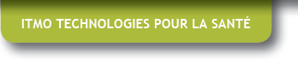 Regenerative Medicine: October 8-9, 2018 organoids and model species Auditorium Biopark Paris, France
ITMO BIOLOGIE CELLULAIRE, DEVELOPPEMENT ET EVOLUTION
October 8th 2018

INTRODUCTION
- 9 :30am -9 :45am Thierry GALLI, Director of ITMO Cell biology, development and evolution
Franck LETHIMONNIER, Director of ITMO Health Technologies
SESSION 1: « Nervous system development and regeneration »
Chairpersons: Bertrand PAIN & Jean-Luc GALZI
- 9 :45am – 10 :20am Orly REINER, Weizmann Institute, Israel. Keynote lecture
« Using human brain organoids on a chip to model development and disease »
- 10 :20am – 10 :50am Caterina BRITO, iBET, Portugal
« Exploiting 3D cell cultures to model disease microenvironment »
- 10 :50am – 11 :20am Olivier GOUREAU, Institut de la Vision, Paris, France
« Retinal organoids from pluripotent stem cells: from development to disease »
- 11 :20am – 11 :50am Muriel PERRON, Neuro-PSI, Paris, France
« Regeneration of the retina from Müller glial cells
- 11 :50am – 12 :00am Ferid NASSOR, CEA/DRF/IBFJ/SEPIA, Fontenay aux Roses, France
« Minibrain for prion-like diseases: a novel platform to engineer and study 3D humanneuroectodermic organoids derived from iPSCs »
- 12 :00am – 12 :10am Rana SALAM, Brain and Spine Institute (ICM), Paris France
« Senescence during gliogenesis: tumor suppression or activator? »
- 12 :15am – 2 :15pm Lunch and poster session

SESSION 2: « Study of organ and tissue development in organoids »
Chairpersons: Joelle AMEDEE, Jean- Luc GALZi
- 2 :15pm – 2 :45pm David HAY, CRM, Edinburg, United Kingdom
« Producing self organizing human liver spheres from pluripotent stem cells »
- 2 :45pm – 3 :15pm Xavier GIDROL, BIG, Grenoble, France
« Organoid-based functional genomics screening in development
and carcinogenesis »
- 3 :15pm – 3 :45pm Gérard GRADWOHL, IGBMC, Strasbourg, France
« Human pluripotent stem cell derived intestinal organoids to study cell fate
and monogenic Diseases »
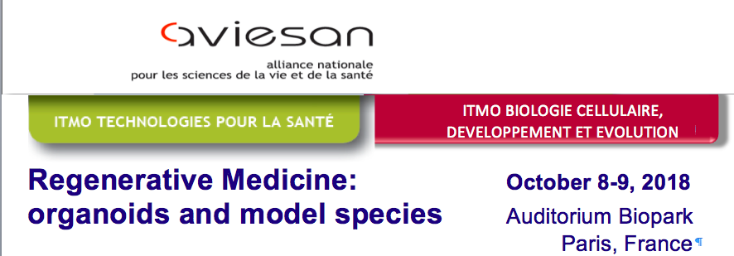
- 3 :45pm – 3 :55pm Géraldine GUASCH, CRCM, Marseille, France
« Generating epithelial transition zones organoids to study organs homeostasis and function »
- 3 :55pm – 4 :05pm Nathalie VERGNOLLE, IRSD, Toulouse, France
« Thrombin modifies growth, proliferation and apoptosis of human colon organoids: a PAR-1 and PAR-4 dependent mechanism »
- 4 :05pm – 4 :15pm Pascale DUPUIS-WILLIAMS, UMR-S1174, Paris Saclay, France
« Bile duct organoids: self-organisation in 3D spheroids or tubes in natural ECM and PEG-derived hydrogels »
- 4 :15pm – 4 :40pm Coffee break

SESSION 3: « In vivo models of regeneration »
Chairpersons: Michel VERVOORT, Bertrand PAIN
- 4 :40pm – 4 :50pm Aurélie de THONEL, Université Paris Diderot, Paris, France
« The acetylation of Heat shock factor 2 by CBP/p300, governs its stability in normal and stress conditions: alteration in the Rubinstein-Taybi syndrome »
- 4 :50pm – 5 :00pm Eve GAZAVE, IJM, Paris, France
« Posterior regenration in the Annelid Playtynereis »
- 5 :00pm – 5 :30pm Eric ROTTINGER, IRCAN, Nice, France
« Regeneration is a partial redeployment of the embryonic gene
regulatory network
- 5 :30pm – 6 :00pm Uwe STRAEHLE, KIT, Karlsruhe, Germany
« Development and regeneration of the nervous system
using the zebrafish as model »
October 9th 2018

SESSION 4: Round table, perspectives and ethics
Chairpersons: Joelle AMEDEE, Jean Luc GALZI, Bertrand PAIN,
Michel VERVOORT

- 9 :00am – 9 :30am Synthesis of Erdyn study, state of the art in France, in EU and in the world
TBA
- 9 :30am – 10 :00am Clinical applications of organoids
TBA
- 10 :00am – 10 :30am Ethics and reglementation
TBA
- 10 :30am – 11 :00am Proposal of the International Organoid Challenge (InOC)
TBA
- 11 :00 am – 12 :00 am General discussion - Round table

****************************************************************************************

